Objective and subjective reduction of cellulite volume using a localized vibrational massage device in a 24-week randomized intra-individual single-blind regression study

T Sadowski ¹, S Bielfeldt ¹, K-P Wilhelm ¹, S Sukopp ², C Gordon ³
Affiliations Expand
- PMID: 32181499

- PMCID: PMC7317706

- DOI: 10.1111/ics.12613
Abstract
in English, French
Cellulite occurs in females and is a common condition of altered connective tissue matrix and increased adipogenicity with visible dimples and orange-peel appearance on the skins surface. Whilst advancements in methods continue to help our understanding, attempts to correct the appearance of cellulite topically have yielded limited success. Various kinds of non-invasive body contouring methods such as whole body vibration have been reported with demonstrable visible improvements in the cellulite condition. The aim of this study was to evaluate volume reduction and improvement of the visible appearance of cellulite as judged both objectively (AEVA-HE phase-shift 3-D fringe projection, macrophotography image grading) and subjectively (questionnaires) after application of a hand-held localized vibrational device over 24-weeks. The study was conducted on 40 healthy female volunteers who were instructed how to use the device on defined areas of cellulite of the outside and rear of the thighs (iliotibial band, and over biceps femoris region respectively). The initial 12 weeks of continuous massage application of the study were followed by a 12 week phase in which volunteers were split into 2 subgroups - one for assessment of regression effects and one for continuous application effects. AEVA (skin surface volume) measurements of cellulite-related dimples correlated with questionnaires and visual image evaluation scoring, in that in the iliotibial region cellulite was significantly reduced at 12 weeks. In the regression subgroup cellulite returned to initial values soon after cessation of treatment, whereas in the continuous application subgroup, cellulite remained diminished. The effect of this device to reduce cellulite as observed in this study proves that continuous use of vibrational massage is beneficial to mitigate visible signs of cellulite.
Keywords: cellulite; claim substantiation in vivo; image analysis; skin profilometry; vibrational massage.
© 2020 The Authors. International Journal of Cosmetic Science published by John Wiley & Sons Ltd on behalf of Society of Cosmetic Scientists and the Société Française de Cosmétologie.
PubMed Disclaimer
Conflict of interest statement
All authors declare that they have no conflict of interest.
Figures
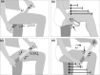
Figure 1
Diagram of mode of use…
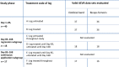
Figure 2
Study design: Study phases, (sub‐)…
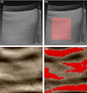
Figure 3
Captured three‐dimensional surface of the…
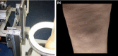
Figure 4
Cellulite Photography Stand (a) and…
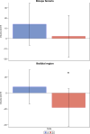
Figure 5
AEVA measurement results of the…
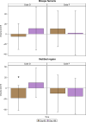
Figure 6
AEVA measurement results of the…
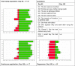
Figure 7
Product acceptance results based on…

https://pubmed.ncbi.nlm.nih.gov/32181499/

