Vibration Training Triggers Brown Adipocyte Relative Protein Expression in Rat White Adipose Tissue

Chao Sun ¹, Ruixia Zeng ², Ge Cao ¹, Zhibang Song ¹, Yibo Zhang ³, Chang Liu ¹
Affiliations Expand
- PMID: 26125027

- PMCID: PMC4466483

- DOI: 10.1155/2015/919401
Abstract
Recently, vibration training is considered as a novel strategy of weight loss; however, its mechanisms are still unclear. In this study, normal or high-fat diet-induced rats were trained by whole body vibration for 8 weeks. We observed that the body weight and fat metabolism index, blood glucose, triglyceride, cholesterol, and free fatty acid in obesity rats decreased significantly compared with nonvibration group (n = 6). Although intrascapular BAT weight did not change significantly, vibration enhanced ATP reduction and increased protein level of the key molecule of brown adipose tissue (BAT), PGC-1α, and UCP1 in BAT. Interestingly, the adipocytes in retroperitoneal white adipose tissue (WAT) became smaller due to vibration exercise and had higher protein level of the key molecule of brown adipose tissue (BAT), PGC-1α, and UCP1 and inflammatory relative proteins, IL-6 and TNFα. Simultaneously, ATP content and PPARγ protein level in WAT became less in rats compared with nonvibration group. The results indicated that vibration training changed lipid metabolism in rats and promoted brown fat-like change in white adipose tissues through triggering BAT associated gene expression, inflammatory reflect, and reducing energy reserve.
PubMed Disclaimer
Figures
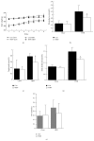
Figure 1
Body weight and fat metabolism…
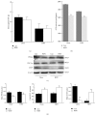
Figure 2
ATP content and BAT associated…
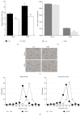
Figure 3
Morphology change in retroperitoneal WAT.…
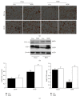
Figure 4
Protein expression of UCP1 and…
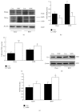
Figure 5
Protein expression of PPAR γ…

https://pubmed.ncbi.nlm.nih.gov/26125027/

